Assignment 03

Kodikara U. S. S. - SKF2400093

# Task 01

In Updown, the movement occurs along the Z axis, so accZ fluctuates while accX and accY stay mostly steady. Conversely, in Snake, movement along the Z axis is constant, with activity in the X and Y directions. As a result, accZ remains largely stable, while accX and accY show variation.



# Task 02

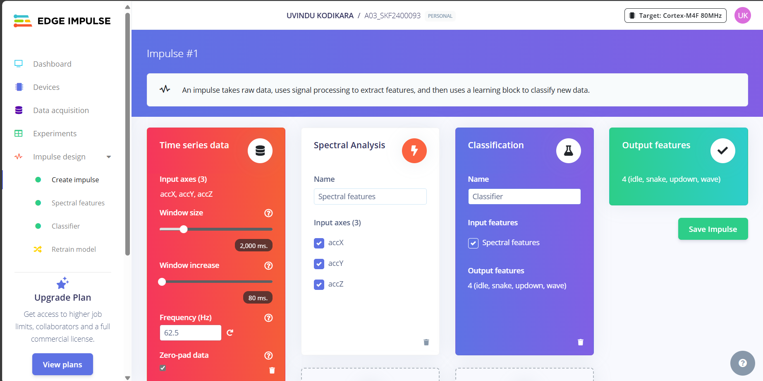

# Task 04

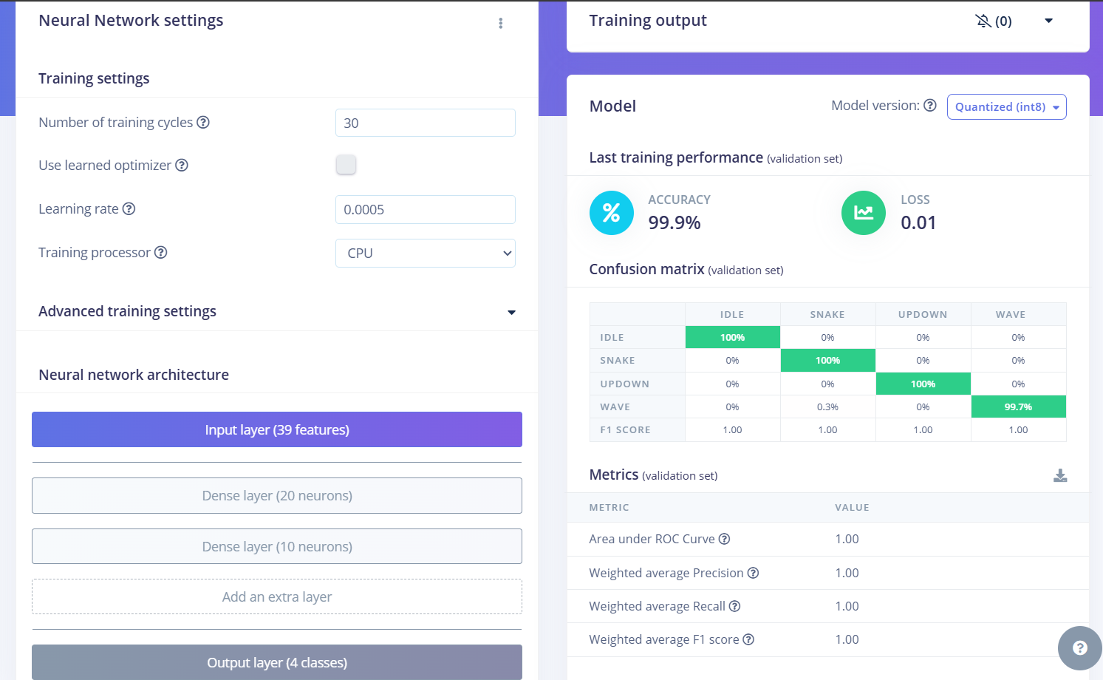

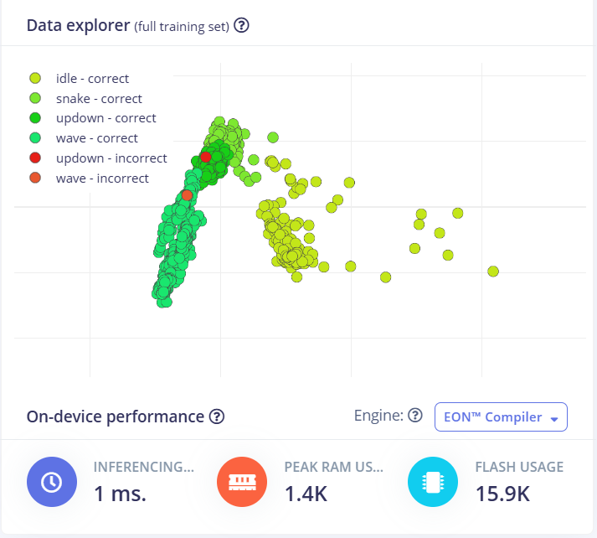

* A learning rate of 0.0005 allows for gradual and stable learning, preventing large shifts in weight adjustments.
* 30 training cycles provide the model with sufficient time to learn while minimizing computational demands.

# Task 05

